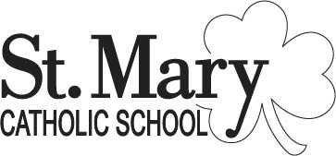
The enrollment link is now open for the 2024-2025 Academic year. This link is for NEW families, current families will log into their FACTS portal to re-enroll.

The link is open for all new families, Preschool 3 through 8th grade. You will create an account with FACTS to begin the enrollment process.

Registration/Enrollment Link for 2024-2025

The link to apply for the Ed Choice Scholarship is:
Ed Choice

2024-2025 Tuition information
Tuition letter

